6A^{th} Grade: Unit 12, Lesson 5

- How much will a person pay if a discount is applied?

Less

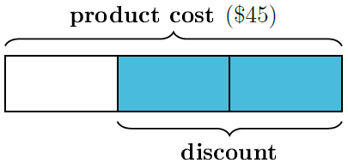
- The tape diagram is divided into thirds. What is the cost of the product after the discount?

$15

- A product was bought for $25.80. The product was selling for $37.75. What is the profit when a product is sold?

$11.95

